***Example 1:*** Disjoint vs. Not Disjoint (overlapping)

A picture that shows the sample space *S* as a rectangular area and events as areas within *S* is called a **Venn diagram**.

|  |  |
| --- | --- |
| Two disjoint events: | Two events that are not disjoint, and the event {*A* and *B*} consisting of the outcomes they have in common: |
|  |  |

***Example 2:*** Independence vs. Dependence   
9 beads: 5 red, 4 blue

Define the following events and choose two beads at random without replacing the first bead before drawing the second:

A = draw a red bead on the first draw

B = draw a blue bead on the second draw

P(A) = 5/13

P(B) = 3/12 if the first bead chosen was red OR

P(B) = 2/12 if the first bead chosen was blue

The probability of drawing a blue bead on the second draw is influenced by what was selected on the first draw.***Example 3.1 and 3.2:***

1. Does the ability of the first person to taste or not taste PTC influence the ability of the second person?

In general, the first person’s ability to taste or not taste does not influence the second. However, the ability to taste PTC is genetic so if the two people were related, one could say the events are dependent.

Assuming independence, the probability of both people being able to taste PTC is…

P(both taste PTC) = P(first persons can taste) × P(second person can taste) =   
0.7 × 0.7 = 0.49

1. Flip a coin three times. Is the result of each flip independent of the other flips?

The coin has no memory and most coin tossers cannot influence the fall of the coin – at least not in a way that would determine the result. These events are independent.

P(three heads in succession) = P(A) × P(A) × P(A) = 0.5 × 0.5 × 0.5 = 0.125

1. Are the colors of successive cards dealt from the same deck independent?

These events are dependent. A standard deck of cards has 26 red and 26 black cards. The probability of dealing a red card first is 26/52 or 1/2. If the first card dealt is red, the probability of dealing a second red card is 25/51. If the first card dealt is black, the probability of dealing a red card next is 26/51.

***Example 4:***

*Given a pair of fair die, define events A and B as possible outcomes of rolling the die…*

A = the sum of the dots is 11

B = a pair is rolled

*Are events A and B Disjoint?* ***YES***

*Given a pair of fair die, define events C and D as possible outcomes of rolling the die…*

C = the sum of the dots is 12

D = a pair is rolled

*Are events A and B Disjoint?* ***NO***

***General Addition Rule for Any Two Events A and B***

*P*(*A* or *B*) = *P*(*A*) + *P*(*B*) – *P*(*A* and *B*)

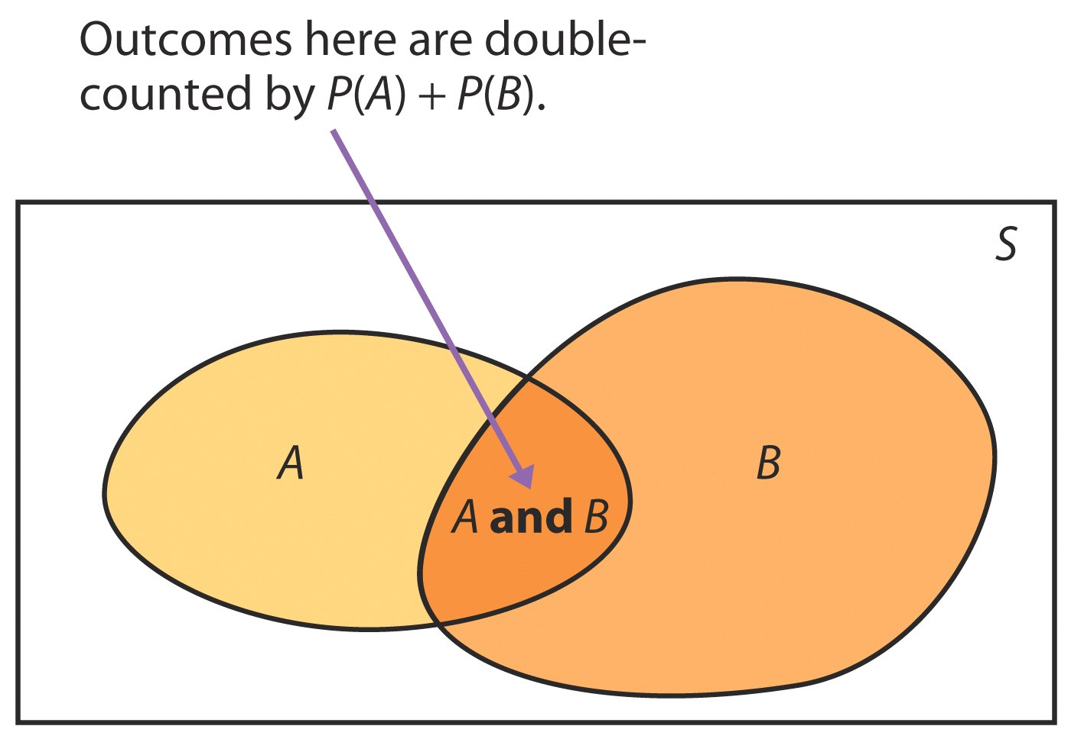

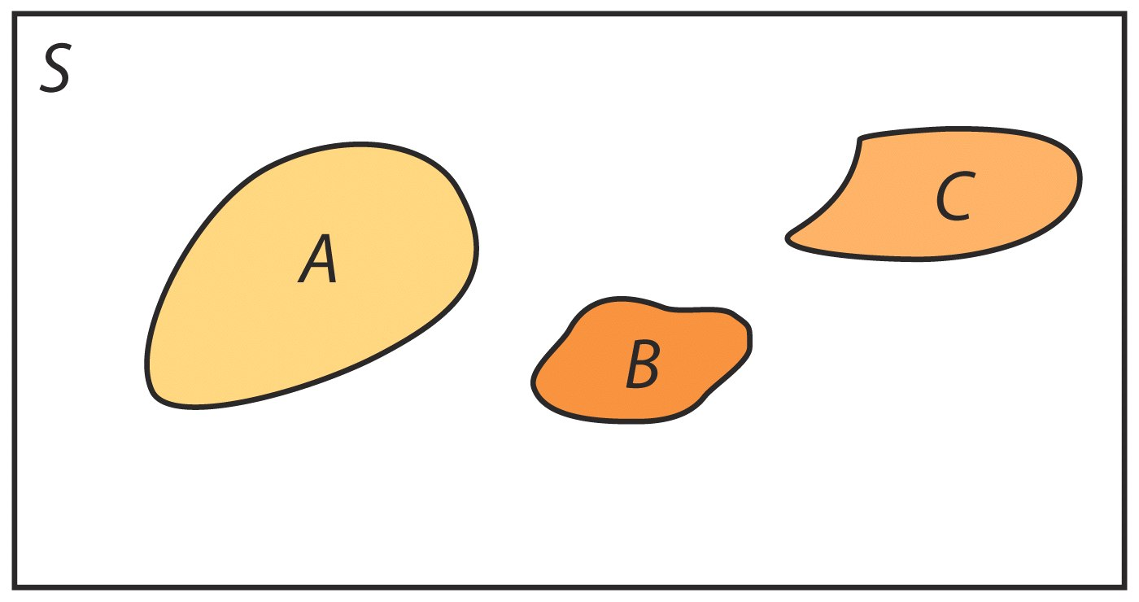

***Example 5.1 and 5.2:***

Not disjoint…

|  |
| --- |
| Neither D nor T 0.17  D AND NOT T 0.33  T AND NOT D  0.07  D AND T  0.43 |

**D=domestic and T=light truck**

1. P(domestic or light truck) = P(domestic) + P(light truck) – P(domestic AND light truck) = 0.76 + 0.50 – 0.43 = 0.83
2. Anything not domestic or a light truck is an imported car.  
   P(imported car) = 1 – 0.83 = 0.17
3. P(domestic car) = P(domestic) – P(domestic light truck) = 0.76 – 0.43 = 0.33

***Example 5.3:***

The following table gives the probabilities for a randomly chosen light motor vehicle sold at retail in the U.S.

|  |  |  |  |
| --- | --- | --- | --- |
|  | **Domestic** | **Imported** | **Total** |
| **Light Truck** | 0.43 | 0.07 | 0.5 |
| **Car** | 0.33 | 0.17 | 0.5 |
| **Total** | 0.76 | 0.24 | 1 |

What proportion of domestic vehicles are cars?

P(car | domestic) = $\frac{0.33}{0.76}$ = 0.4342

What proportion of cars are imported?

P(imported | car) = $\frac{0.17}{0.5}$ = 0.34

**Example 6:**

12.13: PLAN: We construct a tree diagram showing the results (allergic or not) for each of the three individuals. SOLVE: In the tree diagram, each “up-step” represents an allergic individual (and has probability 0.01), and each “down-step” is a non-allergic individual (and has probability 0.99). At the end of each of the 8 complete branches are the value of *X*. Any branch with 2 up-steps and 1 down-step has probability 0.012 . 0.991 = 0.000099, and yields *X* = 2. Any branch with 1 up-step and 2 down-steps has probability 0.011 . 0.992 = 0.009801, and yields *X* = 1.

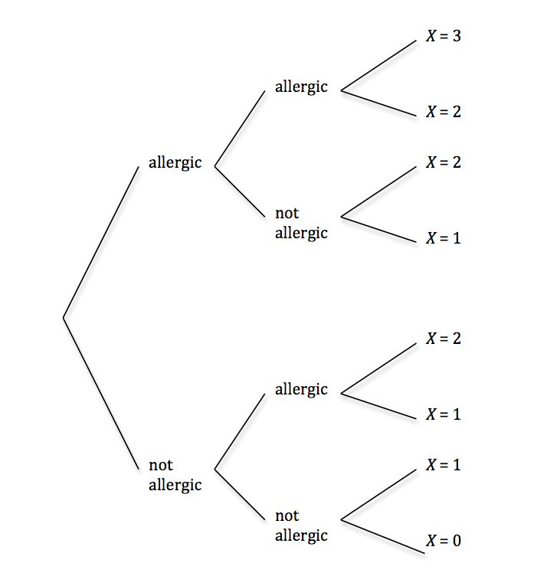

|  |  |  |  |  |
| --- | --- | --- | --- | --- |
| **X** | 0 | 1 | 2 | 3 |
| **Probability** | 0.970299 | 0.029403 | 0.000297 | 0.000001 |